Technical Datasheet TTL to MODBUS RS485 Converter
This bidirectional RS485 to TTL converter module provides a robust hardware interface between standard TTL logic and RS-485 differential signaling. Interfacing seamlessly with a host microcontroller via standard UART (TX and RX) lines, it easily converts signals back and forth to enable long-distance, high-speed, noise-immune serial communication for embedded applications.
RS485 to TTL Converter: -
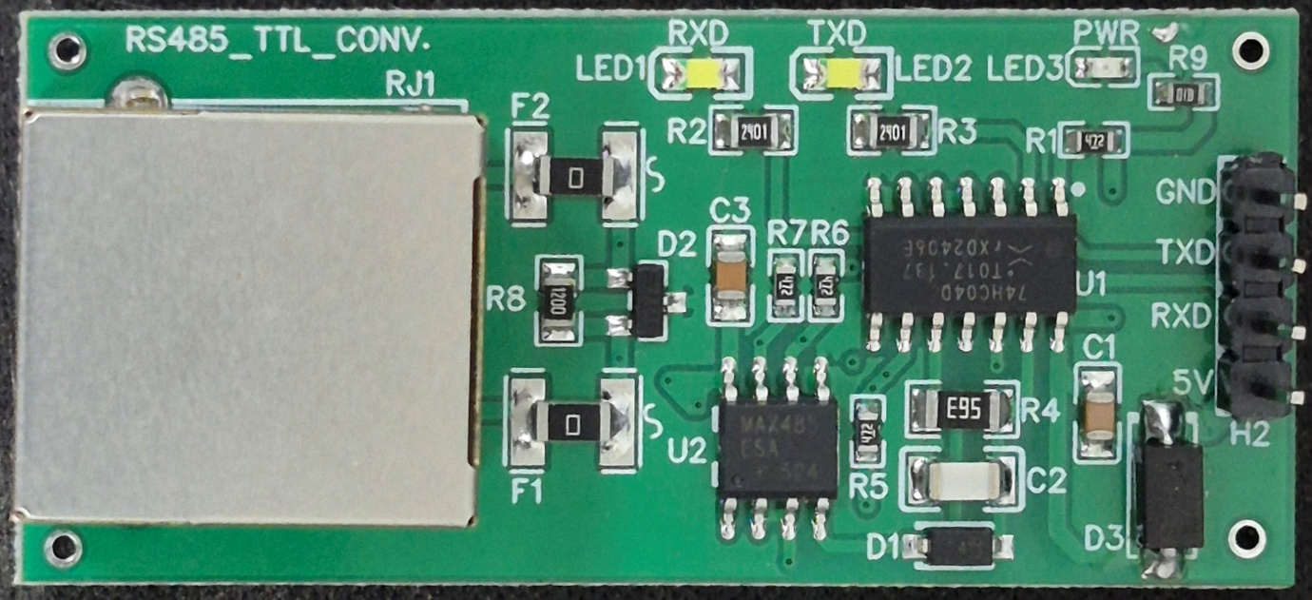
Unlike standard converters requiring the host to manually toggle transmission direction pins, this module features integrated hardware-level automatic flow control. This allows host controllers to implement higher-level protocols (like Modbus RTU or ASCII) strictly using standard serial read/write commands, offering greater flexibility and significantly reducing firmware complexity.
The module includes an onboard RJ45 connector for the RS-485 side, allowing the use of easily sourced, standard twisted-pair network cables to ensure reliable signal integrity and simplified physical wiring. Additionally, dedicated onboard LED indicators for Power (PWR), Transmit (TXD), and Receive (RXD) provide quick visual diagnostics for data flow.
Ideal for applications where long-distance or multi-drop serial communication is required over a single twisted pair, this converter perfectly suits industrial automation projects, custom sensor networks, remote data acquisition systems, and bridging standard microcontrollers into broader RS-485 fieldbus topologies.

Specifications
General –

Host Interface TTL / UART (TXD, RXD)
Network Interface RS-485 (via RJ45 Connector)
Flow Control Automatic Hardware Flow Control
I/O Connector 1 × 5 Pin Header, 2.54 mm Pitch
Power Supply 5V DC Input

Dimensions 23.2 mm (L) × 53.0 mm (W)
Certifications

Additional Features: -
Hardware-Level Automatic Flow Control: No manual transmission direction toggling required.
Standard TTL/UART Interface: Simple TXD and RXD communication with the host MCU.
Onboard RJ45 Connector: Allows easy, secure wiring using standard network cables.
Visual Diagnostics: Dedicated LED indicators for Power (PWR), Transmit (TXD), and Receive (RXD).
Protocol Agnostic: Seamless integration with Modbus RTU, ASCII, and custom serial protocols.
Compact Design: Optimized for easy integration into industrial automation and remote data systems.

Note: -
Use standard CAT5e or higher twisted-pair cables for reliable, long-distance RS-485 communication.
Ensure proper grounding and a stable 5V power supply for optimal signal performance.
TTL logic lines (between your host controller and this module) should be kept short and properly routed to minimize noise.
Crucial for long distances: Ensure a 120Ω termination resistor is installed at both extreme ends of the RS-485 physical bus to prevent signal reflection.

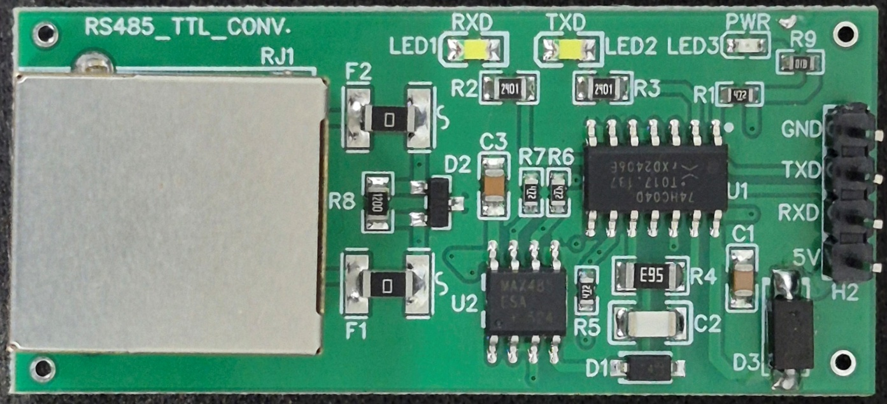
RJ45
Port
Common GND
5V Input Supply

UART
Power LED
Polling LED

Contact us: -
Augmatic Technologies Pvt. Ltd.,
Plot no 6, Shah Industrial Estate II,
Kotambi,
Vadodara – 391510.
Email – Sales@wittelb.com
Support: support@wittelb.raiseaticket.com / +91 94038 92805

